**PROJECT DOCUMENTATION**

**IBM DATA ANALYTICS**

**Dhaanish Ahmed College of Engineering.**

**Project Title: Covid 19 Cases Analysis .**

**Team Members:**

**01.Mohamed Dameem.**

**02. Mohammed Ahsen**

**03.Thoufeeq Ahamed.**

**04. Mohamed wasiq mohideen.**

**05.Salman.**

**Project Documentation: COVID-19 Cases Analysis**

**Description:**

The COVID-19 Cases Analysis project involves utilizing IBM Cognos to perform a comprehensive analysis of COVID-19 cases and deaths data. The primary objective is to compare and contrast the mean values and standard deviations of cases and associated deaths per day and by country within the European Union/European Economic Area (EU/EEA). This project aims to gain insights into the COVID-19 situation, identify trends, and provide data-driven information to aid decision-makers in understanding the pandemic's impact.

**1. Objective:**

The primary objective of the project was to analyze COVID-19 cases and deaths data using IBM Cognos. The goal was to compare and contrast the mean values and standard deviations of cases and associated deaths per day and by country in the EU/EEA. The project aimed to derive insights from the data for better understanding of COVID-19 trends.

**2. Design Thinking Process:**

The project followed a systematic design thinking process encompassing:

* **Analysis Objectives:** Defined specific objectives for analyzing COVID-19 cases and deaths data, such as comparing mean values and standard deviations.
* **Data Collection:** Obtained the provided data file containing COVID-19 cases and deaths information per day and by country in the EU/EEA.
* **Visualization Strategy:** Planned and implemented visualization using IBM Cognos to showcase mean values and standard deviations.
* **Insights Generation:** Derived potential insights from the comparison of mean values and standard deviations of cases and deaths.

**3. Development Phases:**

* **Data Collection and Preparation:** Acquired the dataset from the specified source and prepared it for analysis. Data cleaning and preprocessing were performed to ensure its suitability for analysis.
* **IBM Cognos Setup:** Configured IBM Cognos for data analysis, connected to the dataset, and established the required data models.
* **Data Visualization:** Utilized IBM Cognos to design and create interactive visualizations showcasing mean values and standard deviations, enabling users to explore and understand the COVID-19 data effectively.
* **Insights and Analysis:** Extracted insights from the comparison of mean values and standard deviations, identifying trends and variations in COVID-19 cases and deaths.

**4. Analysis Objectives and Processes:**

* **Objectives:** To compare mean values and standard deviations of COVID-19 cases and deaths per day and by country in the EU/EEA.
* **Data Collection:** Obtained data from the provided dataset, ensuring it covered the relevant geographical and temporal aspects required for the analysis.
* **Visualization:** Leveraged IBM Cognos to create informative charts and graphs illustrating the mean values and standard deviations for better comprehension.
* **Insights Generated:** Discovered variations in COVID-19 cases and deaths across different countries and time frames, identifying patterns and potential correlations.

**5. Impact and Understanding of Insights:**

The insights generated from this analysis contribute significantly to understanding the trends and impacts of COVID-19. The comparative analysis of mean values and standard deviations allows for:

* **Identification of Hotspots:** Pinpointing countries with higher fluctuations in cases and deaths.
* **Temporal Analysis:** Recognizing trends over time, aiding in understanding the pandemic's progression.
* **Correlations and Patterns:** Unveiling potential correlations between cases and deaths, assisting in predicting future trends and supporting healthcare strategies.

This structure provides a comprehensive overview of the project's objective, methodology, analysis objectives, and the implications of insights derived from the analysis of COVID-19 cases and deaths data using IBM Cognos. Adjust and expand upon the outline to fit the specific details and findings from your project.

Implementation of the Project:

Google Colab drive link:

<https://colab.research.google.com/drive/1b_SvrW0j9ZH1Uufeuj0gjlKaFYNmeFoI?usp=sharing>

Output :

DashBoard Analytics

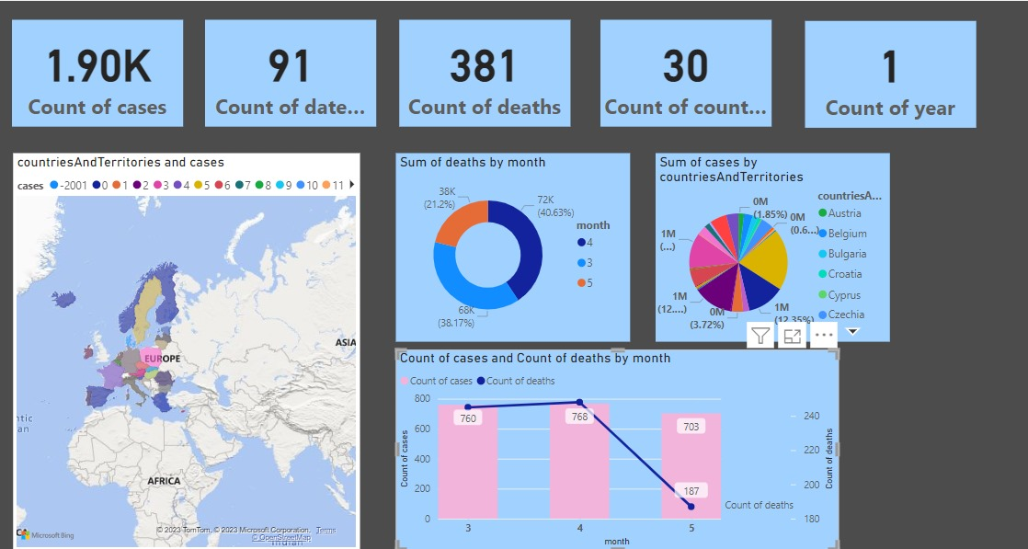

* The Dashboard consists of Analytics visualization based on the different countries and their cases and deaths and mean of the corresponding deaths and cases of the countries.
* We can able to select the different countries to know their mean of deaths and cases.

The implementation process will involve careful data handling, visualization design, interactivity, documentation, testing, and deployment. It will culminate in a system that empowers users to explore and understand the COVID-19 data effectively, contributing to better decision-making and response efforts.